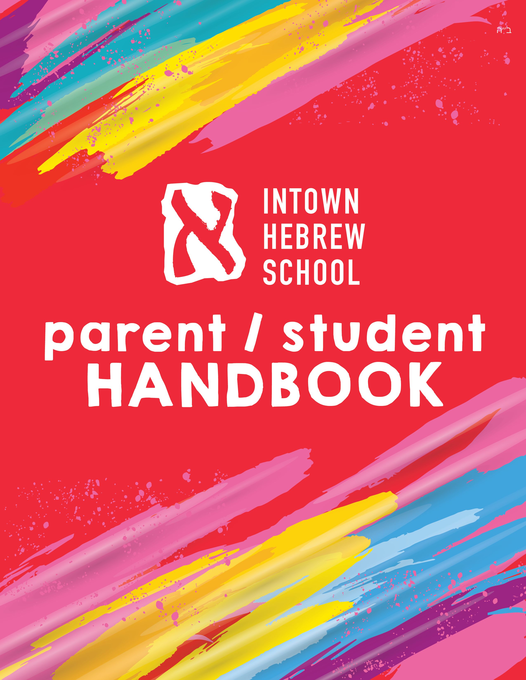

Dear Parents and Students,

Welcome to the Chabad Intown Hebrew School!

We look forward to working together with you and our excellent teaching staff to educate your

children, sharing with them and with you our deep love of Jewish learning.

In order to successfully implement our goals, a home - school partnership is imperative. To

achieve our aims we earnestly seek communication, cooperation and active participation.

Your participation in your child’s Hebrew School education is vital to his/her success. Children

who are encouraged at home will have a more fulfilling Hebrew School experience.

Please help your child by encouraging him/ her to practice the prayers, as well as the Hebrew

reading and comprehension skills learned in school. This is the best way to ensure that the

information will become instilled in his/her mind.

Hebrew reading is taught through an innovative level-based program called

“Aleph-Champ”. Regular practice is necessary for your child to advance.

The family unit is very important to us. During the school year, there will be a number

of events in which all our students and their families will participate. This includes student

performances, holiday parties and programs and an end of the school year celebration.

I hope that you will find this handbook informative. It contains the general information you will

need about our school as well as a school calendar and school supply list, please make sure

to read it with your child before the first day of school.

Please feel free to call me with any questions. I can be reached on my cellphone at (678) 637-1785 or by e-mailing me at [mussy@chabadintown.org](mailto:mussy@chabadintown.org)

I look forward to spending and exciting, rewarding and engaging year with you and your family.

Mrs. Mussy Groner



Our philosophy is that every Jewish child is entitled to a basic Jewish education regardless of family affiliation or membership. To achieve this goal, we have opened our Hebrew School to you.

The Chabad Hebrew School offers a warm and lively Jewish atmosphere where children can attain a unique and exciting awareness of their Jewish identity.

Indeed, a child equipped with an education and a feeling for Judaism’s beautiful teachings, traditions, and historical lessons, is a child better equipped to face the awesome moral challenges of today’s society.

Judaism has always taught and stressed the importance of knowledge. Through our Hebrew

School, we will try to instill in the children a strong thirst for study; to gain knowledge and

understanding of what Judaism stands for, a feeling for their rich heritage, a sense of responsibility, a desire to continue exploring Judaism and a positive picture of themselves as Jews.

Our most underlying approach is for the children to enjoy the time spent at Hebrew School so that they are left with positive feelings and fond memories or their Jewish education. Our program is thus carefully blended with songs, games, incentives, arts and crafts, dramatics, family celebrations, and other exciting co-curricular activities.

We encourage you to spread the word to your family and friends about this unique learning program, and as a parent, to get involved and keep in touch with our school. You may very well discover that your child’s Hebrew School education at the Chabad Hebrew School will add an enriching spiritual dimension to the life of your entire family.

Our goal is that every student should...

* Attain a strong feeling of identity with the Jewish heritage and to develop a sense of love and pride in being Jewish.
* Gain knowledge and understanding of the Mitzvot, traditions and practices that Judaism stands for, to study the morals, values, and ethical behavior mandated by the Torah, and to develop an appreciation for all the Jewish holidays.
* Master the skills of Hebrew reading and to gradually develop the ability to understand basic Hebrew words, with an emphasis on the prayers, so that the student will feel comfortable when attending services.
* Discover and explore the incredible history of the Jewish people and its relevance for all times.
* Express their opinions and questions about G-d, Torah, and religion and to understand the

importance of these things in today’s society.

* Attain a Jewish perspective on life and maintain Jewish feelings and involvement beyond the years at Hebrew School, and to ultimately perpetuate this to future generations.



**AGES:** Our Hebrew School program is designed for students from Kindergarten through 7th grade.

**HOURS:** All classes meet on Sundays from 9:30 AM - 12:00 Noon

**LOCATION:** Classes take place at Chabad Intown located at 730 Ponce de Leon Place NE, Atlanta 30306.

**TUITION:** The cost of Hebrew School is $1,200 per year, which includes a $100 registration fee. In the interest of increased security for the Intown Hebrew School, IHS provides a security officer during the hours of Hebrew School drop off and pick up. We therefore also have a $100 security fee, applied once per family.

For your convenience, we have three payment options:

* One payment, in full before August 1 of the Hebrew School year.
* Two payments, August 1 and January 1 of the Hebrew School year.
* Nine payments, due the first of each month starting in September and ending in May of the Hebrew School year.

The above may be paid by check, cash or credit card. Post-dated checks must be received by the first day of school.

**PARENT – TEACHER RAPPORT:** Our school is run by a staff of professional and dedicated individuals. Each of them spends hours planning their lessons and designing creative methods of injecting fun and excitement into the program. They are deeply concerned about the progress of each individual student, and would be more than willing to spend time discussing your child’s progress with you. Please feel free to email your child’s teacher at with any questions or concerns.

**GETTING INVOLVED:** We have lots of opportunities for our parents to be involved in Hebrew School. Volunteering at our programs, driving field trips, and helping out during Aleph Champ are some of the ways you can be involved in your child’s Jewish education, and we always welcome your participation.

**CONFIDENTIAL INFORMATION:** It is of great importance for the teacher to have any information which can provide for the optimum learning situation. Information of a physical, social, and psychological nature can aid a teacher in planning instructions for each child. Without this knowledge, teachers are at a disadvantage and may be unable to provide the kind of support needed. Such information should be transmitted either in writing, or by a private conference with the director, who will make it known to the appropriate teacher.

**EMAIL:** Almost **all** of our communication takes place via email. Please make sure we have a current email address on file, and read through our weekly emails.

* 50 pennies for Tzedakah
* Kippah & Tzitzit (for boys)
* 1 box crayons

**ATTENDANCE:** The greatest gift that you as a parent can give to your child is constant encouragement. Too much is never enough! The first step for parents and children is to realize that attendance is the key to a successful school year. Children who take days off not only miss important school work, but also create an atmosphere of “Hebrew school isn’t really that important.” Parents should schedule all appointments on non-school days. Students who miss class on a regular basis disrupt their learning and the learning of other students.

**PUNCTUALITY:** Please be sure that your child arrives at Hebrew School on time. Children who arrive late miss school work and disrupt classes already in session. Please see to it that your child is picked up from school on time as well.

**BEHAVIOURAL EXPECTATIONS:** The Chabad Hebrew School strives to create an atmosphere that reflects our Jewish values. We take pride in our student body who respect teachers, fellow students, and the property of school. We expect each student to:

* Be courteous to fellow students and staff members.
* Follow classroom directions promptly and quietly.
* Complete all class assignments and homework.
* Come prepared with textbooks and supplies to each session

**SUPPLIES**

* 2 ballpoint pens
* 2 pencils
* 1 box markers
  + - Hebrew School Bag (new students will receive one)

**FOOD:** No food of any kind can be brought to school. Any snacks or drinks will be provided by the school.

**FIRST AID:** Minor injuries will be taken care of by the school staff. Should anything serious occur, G-d forbid, the parents or emergency contact will be contacted and the child will be taken to the nearest hospital if necessary.

**SCHOOL RECORDS:** Parents are asked to please notify the school director of any change of address, telephone number, as well as any changes regarding emergency situations. This is so that we can keep our records up to date and allow us to communicate with the home when necessary.

**VISITATION:** Parents are always welcome to visit the classroom. Please be sure to speak to the teacher in advance. Teachers will be available to converse with parents after class or they will be pleased to arrange an appointment or telephone conference.

**INCLEMENT WEATHER:** In the event of inclement weather not allowing for classes on a school day, parents will be notified by email if classes will be on or not.

**Photos and Social Media:** Weekly photos are uploaded to our google photos album. Take a peek into the classroom from behind the scenes videos and photos up on our Instagram and Facebook weekly.



In order for our Hebrew School program to be most effective, the home and school

must work hand in hand to promote a close relationship.

The following are a few suggestions to aid you in allowing this to happen.

* A growing child needs plenty of rest. Teachers report that often a sluggish, indifferent child in the classroom will not have had enough sleep the night before.
* Set a reasonable bed time the night before a school day and be consistent.
* Many of our students are involved in other extra-curricular activities (e.g. sports, music, etc.). These are important, however please make your child’s Jewish education a priority.
* There is a direct correlation between a student’s attendance, and his/her interest, achievement and attitude. Every time your child is absent, there is a loss of continuity to the program. Keep your child in school regularly.
* It is unfair to your child and his/her classmates to be late. Please help your child come to Hebrew School on time.
* The place to voice your concerns about the school is with the school director and teacher. Please do not discuss school issues in the presence of your child.
* Participation in synagogue services and celebration of Jewish holidays will greatly enhance your child’s interest in Judaism and strengthen his/her Jewish identity. Our director and teachers are always willing to provide resources, share their expertise, and help however possible.
* Show your child that you are interested in his/her Jewish education. Spend time with your child reviewing what he/she has learned in class and listening to him/her read Hebrew to you. This will greatly encourage and help foster a strong and positive identity.



**HEBREW:** The Chabad Hebrew School teaches children to recognize, read and write the Hebrew alphabet, recite prayers in Hebrew and be at ease with the Siddur (Prayer Book). Additionally, we teach our students to understand the structure of the Hebrew language and begin to develop conversational Hebrew.

**TORAH:** We will delve into foundational storied from the Torah. This subject provides our students with an overview of each portion, its highlights, and practical lessons that apply to daily life.

**PRAYER:** This area is aimed at the study and understanding of prayer and the Siddur, focusing on the meaning of each prayer as well as some key words to remember. We want each child to be comfortable with the Siddur during services.

**HOLIDAYS:** Lessons on each Jewish holiday will fill the calendar as we proceed from Rosh Hashanah and the High Holidays through the holiday of Shavuot. The students will have a deeper understanding of each holiday and its traditions.

**JEWISH VALUES AND ETHICS:** The students will read and discuss stories and case scenarios that have practical application to their everyday life. They will understand that our religion is based on a G-d given set of values and morals and not on what is popular or in vogue.

**MITZVOT:** The children at Hebrew School will learn about the many Jewish practices and the reasons they are performed. The Jewish lifecycle will also be covered in this class.

**JEWISH MUSIC AND SONG:** Led by our teachers, the students will learn many Jewish songs connected to the lessons being taught.

**ARTS AND CRAFTS:** Led by our art director Justine Rubin, the students will enjoy doing many different art projects with Jewish holiday and Mitzvah themes that will add a taste of Jewish life to your home.

**CKids:** The Ckids programs are part of our Hebrew School curriculum. Through a series of stimulating, hands on workshops, these programs effectively provide a unique and creative educational tool that links Jewish learning to Jewish practice and living. The whole family is encouraged to join us and participate in these workshops. The dates of these events are on our calendar and details will be announced. Stay tuned!

**EXTRA CURRICULAR ACTIVITIES:** The Chabad Hebrew School will offer a variety of extra-curricular activities such as guest speakers, Shabbatons, field trips, contests, and more. These events will allow our students and their families to experience Judaism in its entirety, both in and out of the classroom.